

**AWS Lab #5**

**By Diego Santos**

**Intro**

Today we’ll be creating an Amazon ClouldFront Distribution using Amazon S3

**Screenshots**

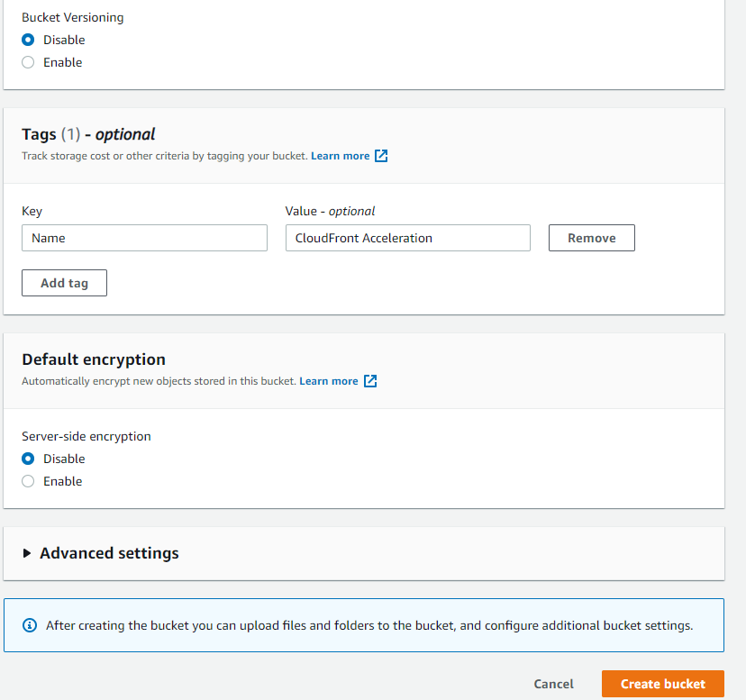

(Creating bucket)

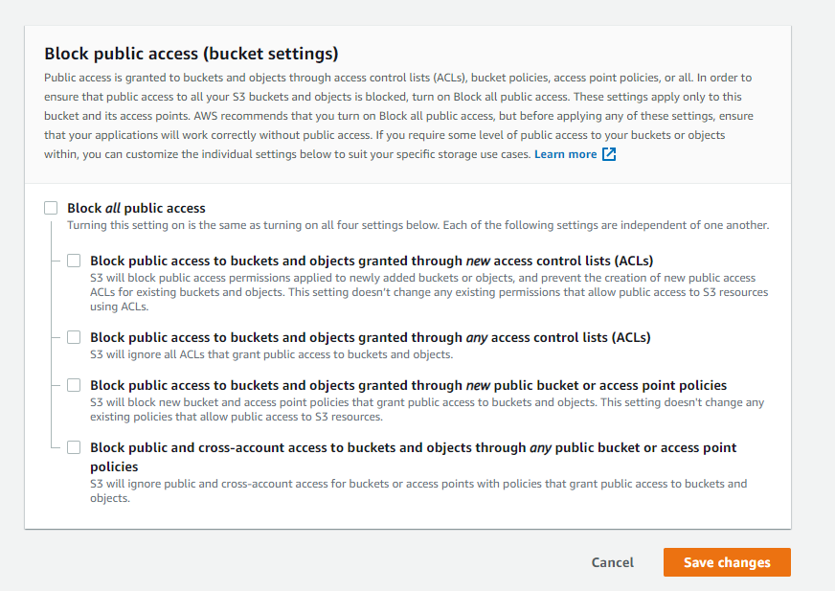

(Allowing public access)

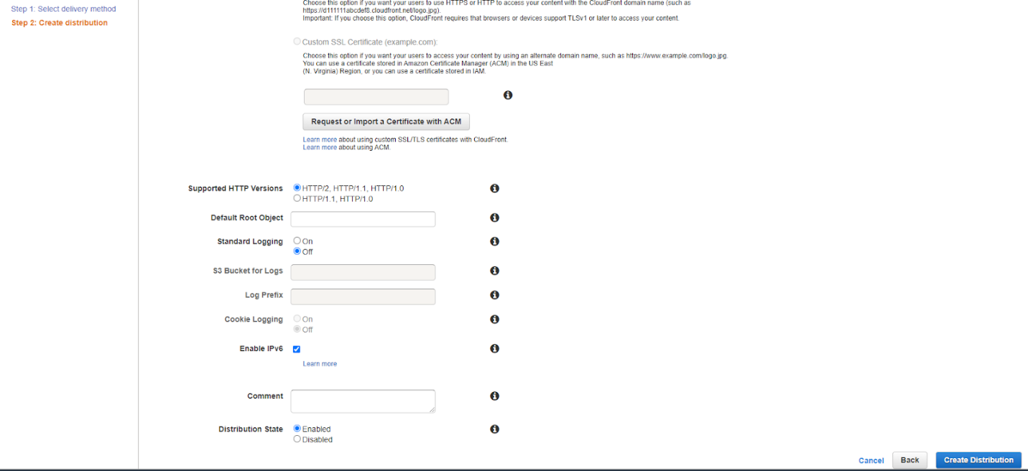

(Creating cloudfront distribution)

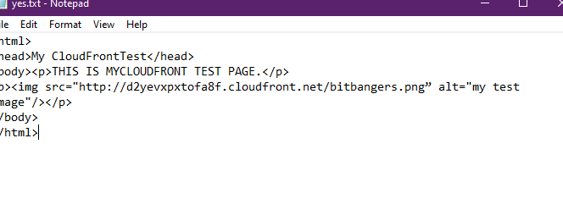(Creating HTML code)

**Question**

1. Cloudfront is a delivery network by Amazon
2. It aids with web creation and distributions
3. S3 is storage whereas Cloudfront is distribution
4. Where end users access AWS services
5. low latency and high performance edge locations through the world

**Problems**

I didn’t have any problems when setting up this lab